Custom Image with ORM stack

Contents

1. Introduction 3
2. Workflow diagram to deploy the stack 3
3. Create stack for Custom Images 5
4. Plan the Job 8
5. Apply the Job 9
6. Verify in the Console 9
7. Destroy the stack 11

Introduction
Oracle Cloud Infrastructure uses images to launch instances. User can specify an image to use when you launch an instance.
User can create a custom image of an instance's boot disk and use it to launch other instances. Instances user launch from your image include the customizations, configuration, and software installed when you created the image.

Workflow diagram to deploy the stack

Below diagram shows how the Terraform Artifact are applied in the OCI. While creating a ORM stack, using terraform deliverables Init, Plan and Apply is the flow to provision the resource in the OCI. We can have the deliverables in any of below.

- GitLab/GitHub Repo
- Bitbucket
- Can be in folder/.zip in the local disk
- Object Storage Bucket
- Can be in compartment
- Oracle provided Template


Create stack for Custom Images

Go to OCI Console Developer Services Resource Manager Stacks select the compartment Create Stack

My Configuration Folder Browse Select the “custom_image_0” folder that contains the terraform Upload.
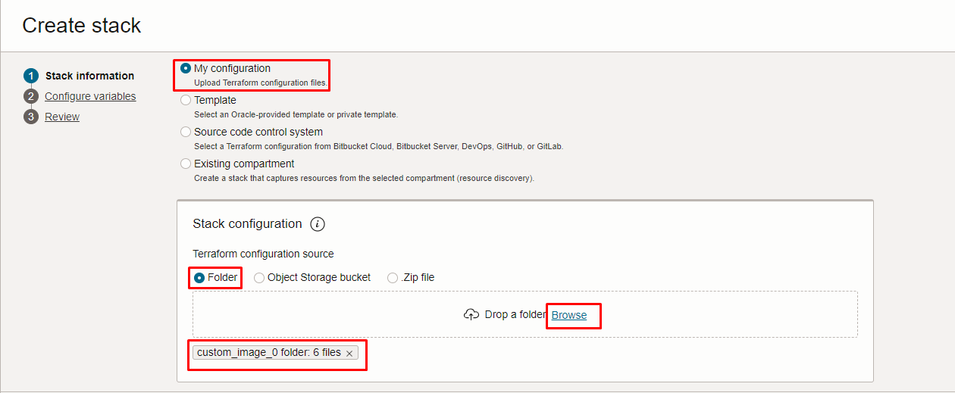
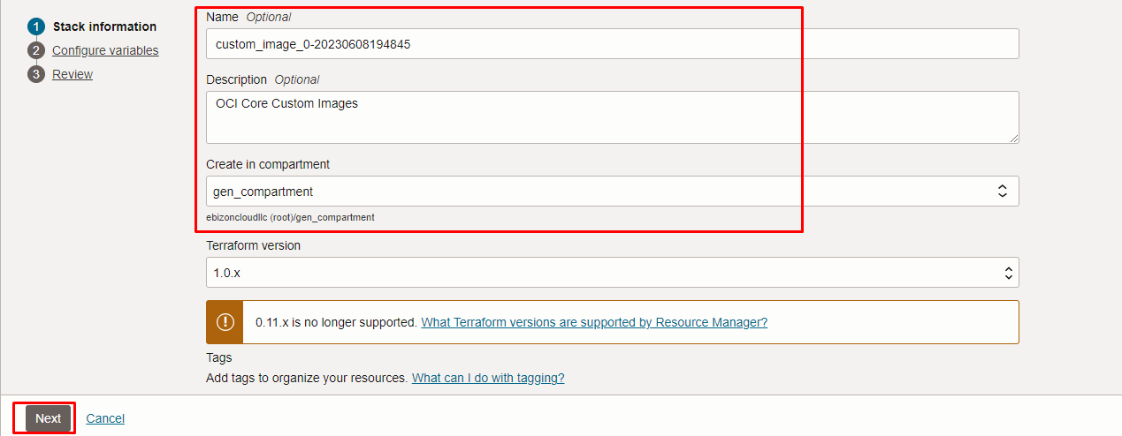

Click “NEXT”

Select the parameters as per the below screen,

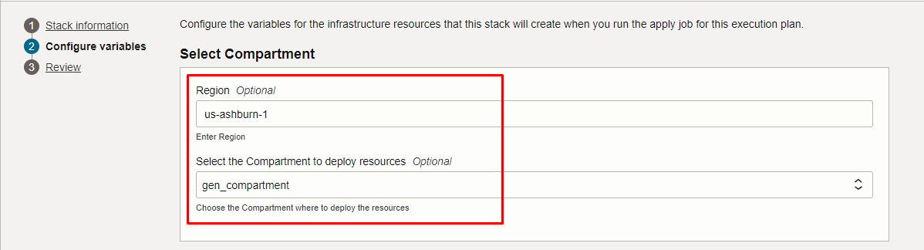
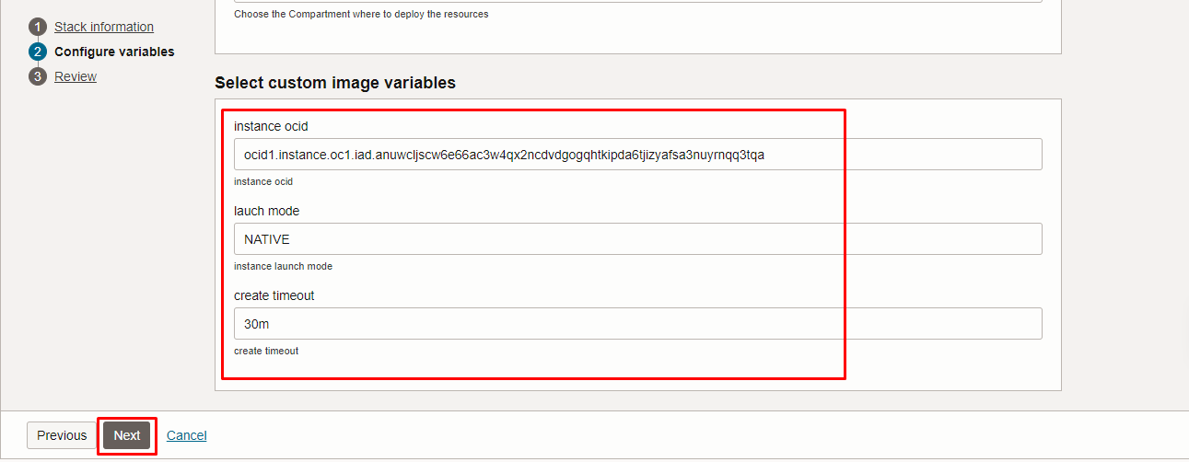

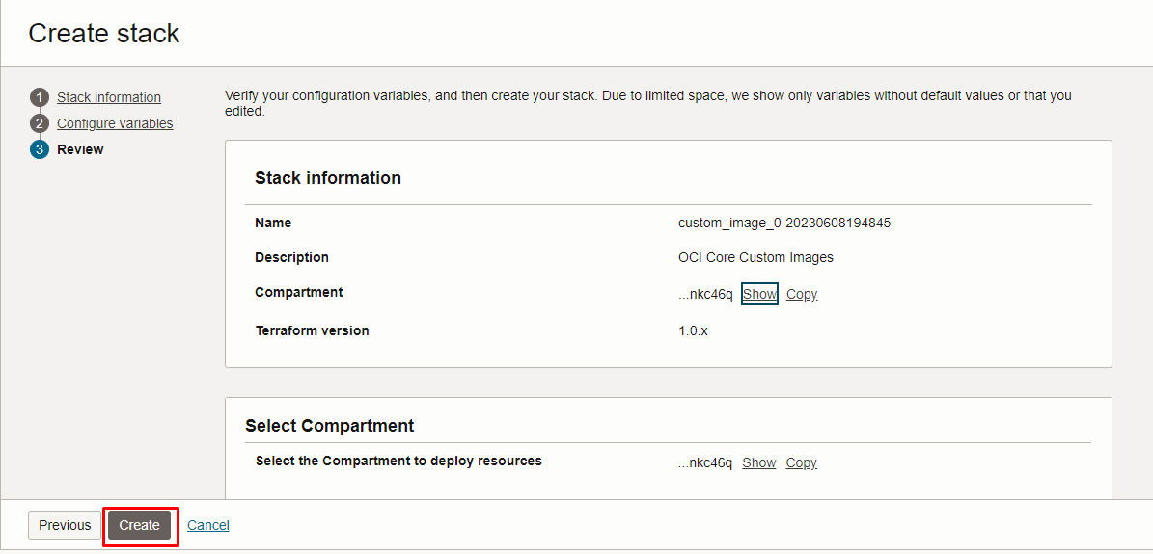

Click “NEXT” Click “CREATE”

Plan the Job
Click the “Plan”

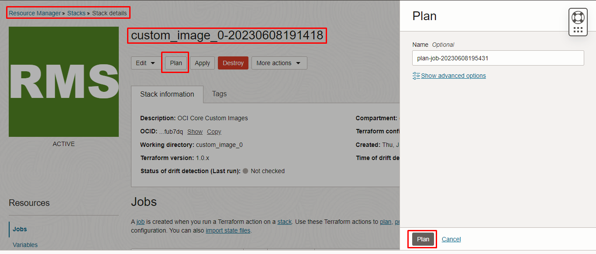

Verify the Plan is successful.
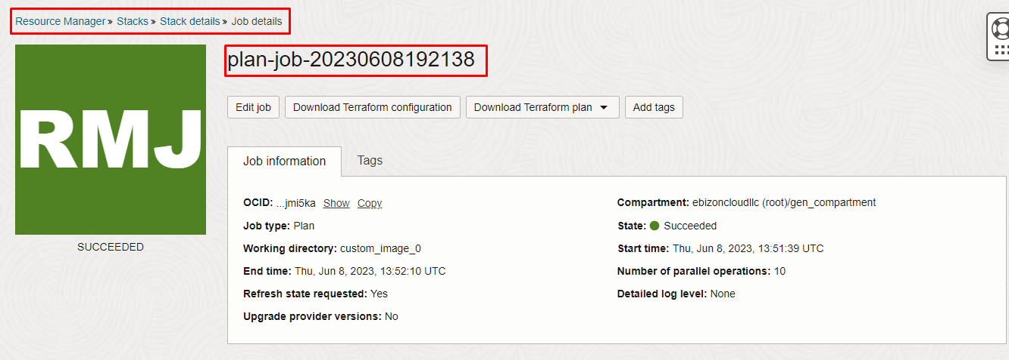
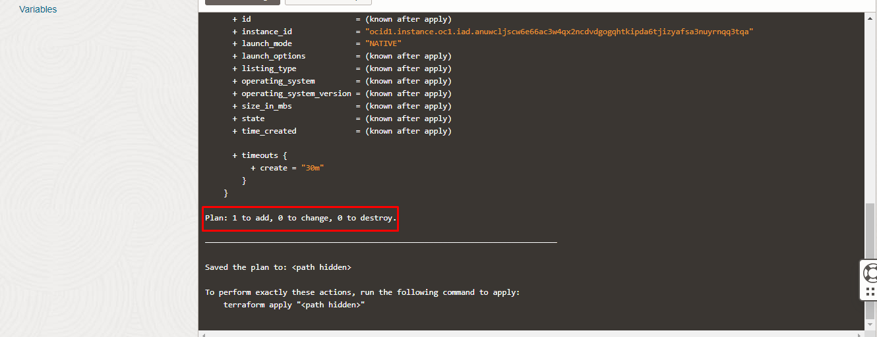

Apply the Job
Once the “plan” is success, now click “Apply”
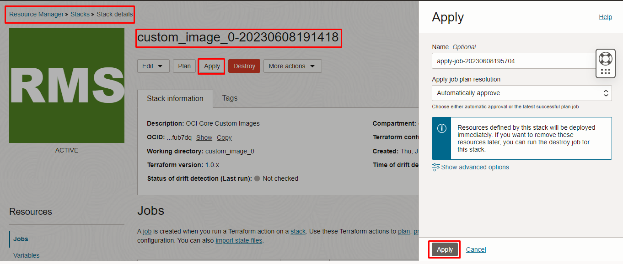
Verify the Apply is successful.
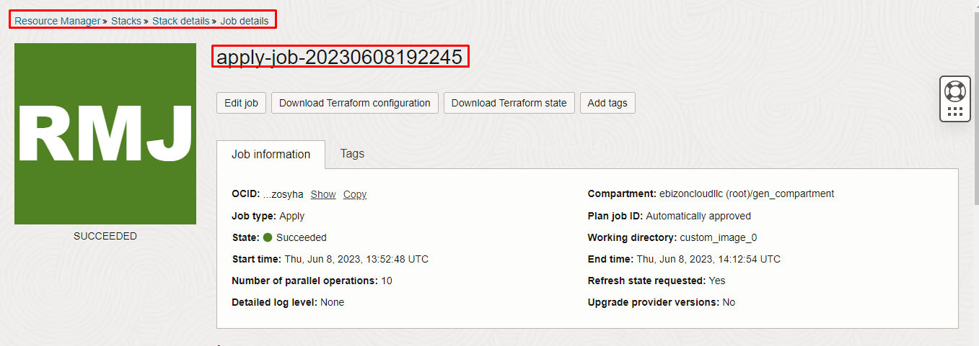
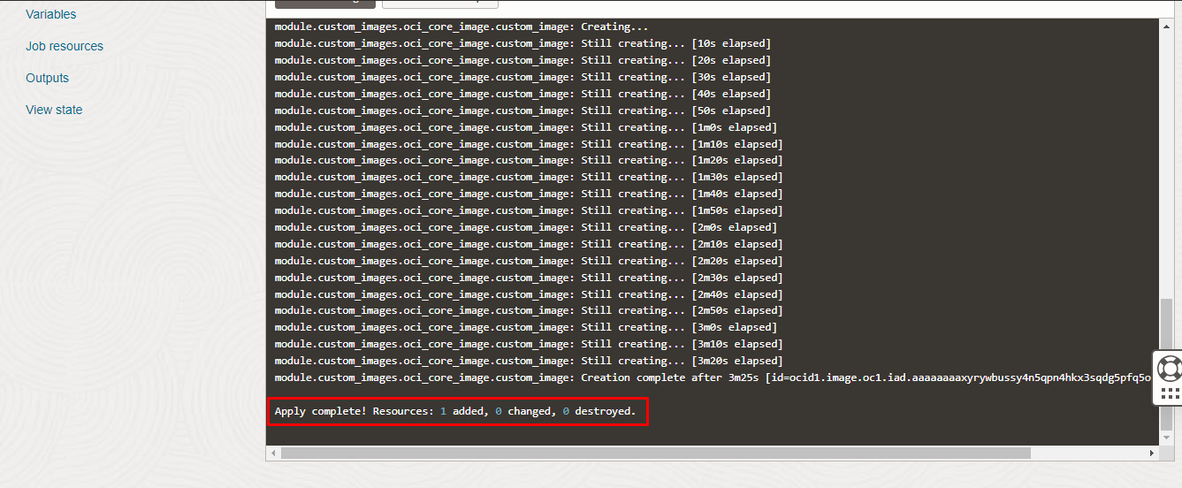

Verify in the Console

Go to OCI Console Compute Custom Images

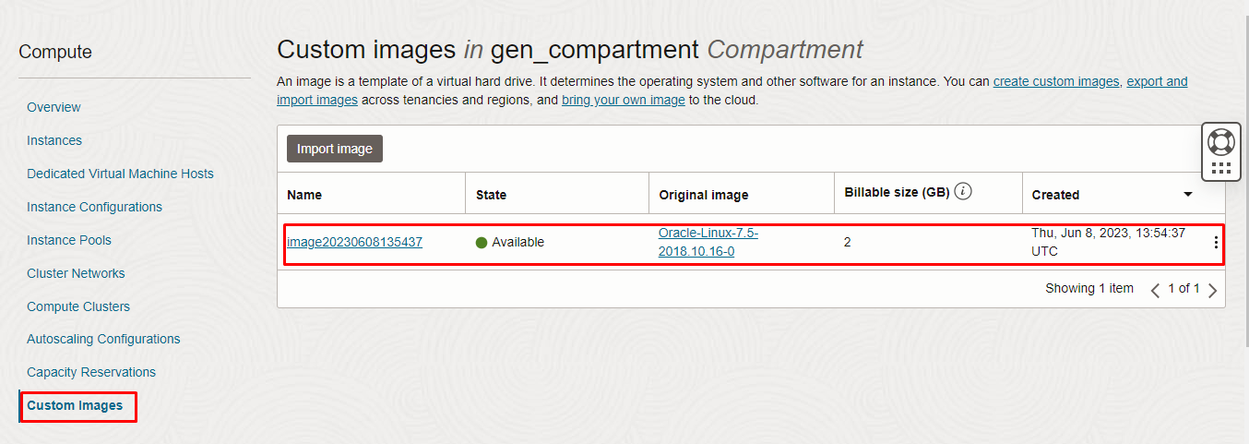

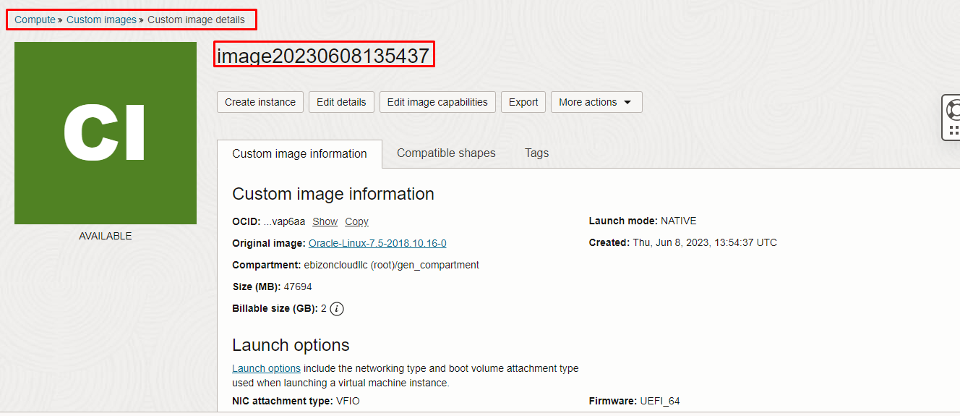
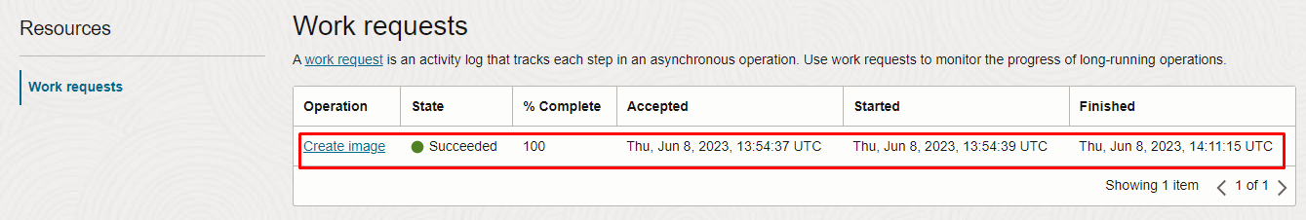

Destroy the stack
Create a destroy job in Resource Manager to release resources associated with a stack and clean up the tenancy. Once destroyed data cannot be recovered from resources.
